Question 1
- use question_1;
- CREATE TABLE questionOne(item_id text, category text, tags int, related_items list<int>, description text, PRIMARY KEY(item_id, category));
- SELECT * FROM questionOne;
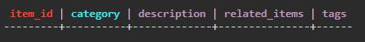

- INSERT INTO questionOne(item_id, category, tags, related_items, description) VALUES('item1', 'service', 2, ['item2'], 'This is a description');
INSERT INTO questionOne(item_id, category, tags, related_items, description) VALUES('item2', 'service', 3, ['item1', 'item3'], 'This is a description');
INSERT INTO questionOne(item_id, category, tags, related_items, description) VALUES('item3', 'service', 1, ['item2'], 'description');
SELECT * FROM questionOne;
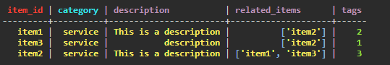

- For determining if a description is long or short we can use the len() function to get the length of that string and if we say maybe a long description is one with more than 20 characters then if len(description) returns a value greater than 20 we can say that it is a long description or short description if less than 20
Question 2
2.1) For this question, since vibration levels are collected at different points of the same machine, it means we will have multiple vibration levels for this same machine, I am going to use a map to collect multiple vibration levels and use the point name as the key e.g({‘point1’, 24})
The above statement applies to the temperature levels of different components e.g({‘Component1’, 45})
Then for the power consumption I will use a float, a text for operational status and timestamp for time
And since all of these make up one reading and each machine can have more than 1 reading, we will use a user-defined data type called ‘readings’ to hold records of multiple readings on a machine

2.2)
- use question_2;
- CREATE TYPE readings(vibration_levels map<text, decimal>, temperature_readings map<text, decimal>, consumption float, status text, time timestamp);
- CREATE TABLE questionTwo(machine_id text PRIMARY KEY, reading frozen<map<text, readings>>);
- INSERT INTO questionTwo(machine_id, reading) VALUES ('Machine_1', {'Reading 1': {vibration_levels: {'motor': 0.5, 'gearbox': 0.2},temperature_readings: {'engine': 85.0, 'coolant':70.0},consumption: 1200, status: 'running', time: toTimestamp(now())}, 'Reading 2': {vibration_levels: {'motor': 0.5, 'gearbox': 0.3}, temperature_readings: {'engine': 87, 'coolant':72}, consumption: 1150, status: 'running', time: toTimestamp(now())}});
- INSERT INTO questionTwo(machine_id, reading) VALUES ('Machine_2', {'Reading 1': {vibration_levels: {'motor': 0.7, 'bearing_01': 0.1},temperature_readings: {'engine': 90.0, 'coolant':65.0},consumption: 1500, status: 'running', time: toTimestamp(now())}});
- SELECT * FROM questionTwo;
- 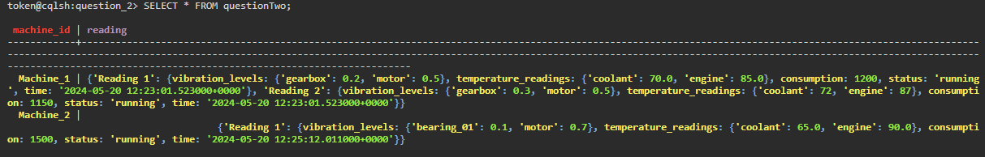

2.3 SELECT reading[-1] FROM questionTwo WHERE machine_id=’Machine_1’;

QUESTION 3
=========================================================================
Create Node
LOAD CSV WITH HEADERS FROM 'file:///customer.csv' AS row
CREATE(:customer{
custID: row.ID,
salesRep: row.salesRep,
lastName: row.LastName,
firstName: row.FirstName,
phone: row.Phone,
address: row.Address,
city: row.City,
country: row.Country,
creditLimit: row.CreditLimit
})

LOAD CSV WITH HEADERS FROM 'file:///payment.csv' AS row
CREATE(:payments{
checkNo: row.CheckNum,
customerID: row.CustomerID,
paymentID: row.PaymentDate,
amount: row.Amount

})

LOAD CSV WITH HEADERS FROM 'file:///orderProduct.csv' AS row
CREATE(:orderProduct{
id: row.ID,
orderID: row.OrderID,
productCode: row.ProductCode,
quantity: row.Qty,
price: row.PriceEach

})
LOAD CSV WITH HEADERS FROM 'file:///orders.csv' AS row
CREATE(:orders{
id: row.ID,
customer: row.Customer,
orderDate: row.OrderDate,
requiredDate: row.RequiredDate,
shippedDate: row.ShippedDate,
orderStatus: row['Status']

})
LOAD CSV WITH HEADERS FROM 'file:///office.csv' AS row
CREATE(:offices{
code: row.Code,
city: row.City,
phone: row.Phone,
address: row.Address1,
state: row.State,
country: row.Country,
territory: row.Territory

})

LOAD CSV WITH HEADERS FROM 'file:///employee.csv' AS row
CREATE(:employees{
id: row.ID,
officeCode: row.OfficeCode,
reportsTo: row.reportsTo,
lastName: row.LastName,
firstName: row.FirstName,
extension: row.Extension,
email: row.Email,
jobTitle: row.JobTitle

})

Create Relationships
Products are considered types of product lines
A customer makes an order
Employees assist customers
Some employees report to some(maybe managers or supervisors)
An employees works at a certain office/branch
A product in an order belongs to a products table
A product is part of an order

MATCH (p:products), (pl:productLines)
WHERE p.productLineID=pl.id
CREATE (p)-[:TYPE_OF]->(pl)

MATCH (o:orders), (c:customer)
WHERE o.customer=c.custID
CREATE (c)-[:ORDERED]->(o)

MATCH (e:employees), (c:customer)
WHERE e.id=c.salesRep
CREATE (e)-[:ASSISTED]->(c)

MATCH (e:employees), (s:employees)
WHERE e.reportsTo=s.id
CREATE (e)-[:REPORTS_TO]->(s)

MATCH (e:employees), (o:offices)
WHERE e.officeCode=o.code
CREATE (e)-[:WORKS_AT]->(o)

MATCH (p:products), (op:orderProduct)
WHERE p.code=op.productCode
CREATE (op)-[:IS_PRODUCT]->(p)

MATCH (o:orders), (op:orderProduct)
WHERE o.id=op.orderID
CREATE (op)-[:PART_OF]->(o)

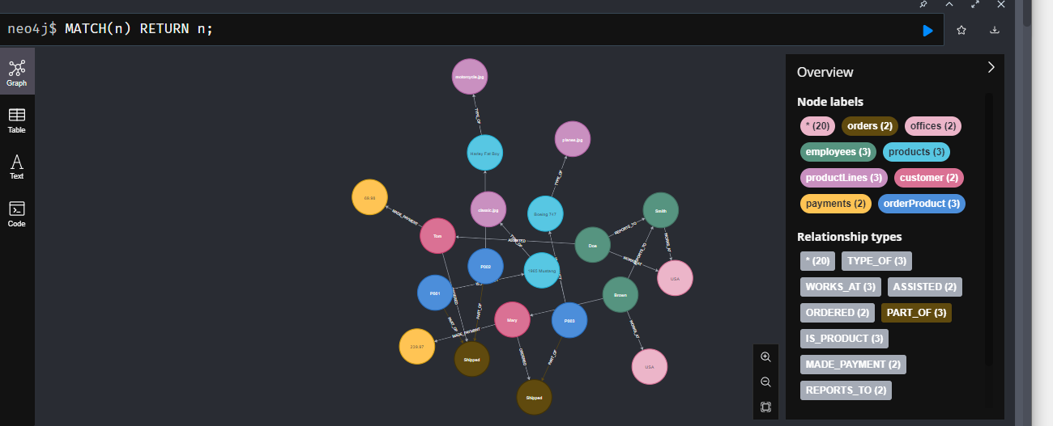

3.2.1 MATCH (p:products), (pl:productLines)
WHERE p.productLineID=pl.id
RETURN p, pl
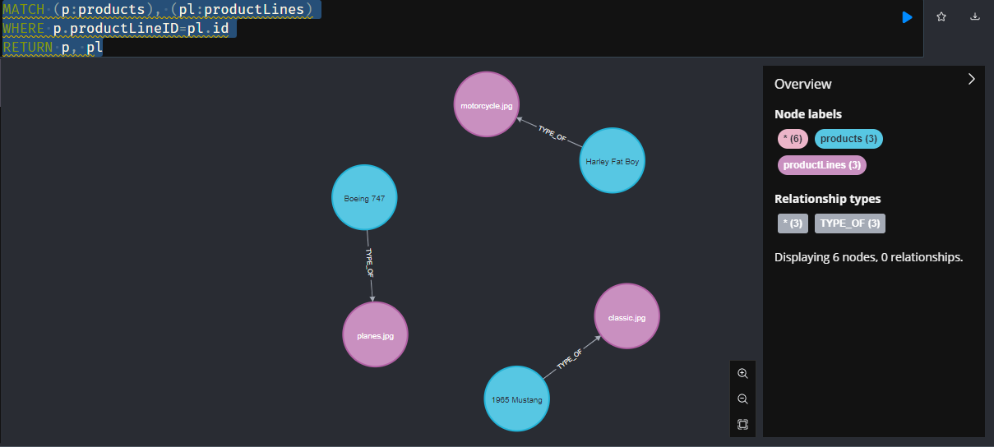
3.2.2 MATCH (e:employees)-[:WORKS_AT]->(o:offices)
return o, count(e)
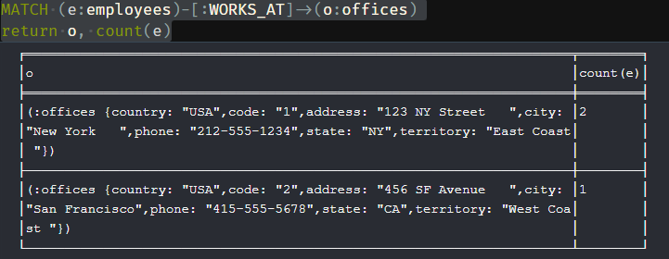

3.2.3 MATCH (p:products), (op:orderProduct)
WHERE op.orderID='O001' AND op.productCode=p.code
RETURN p.productName, p.code
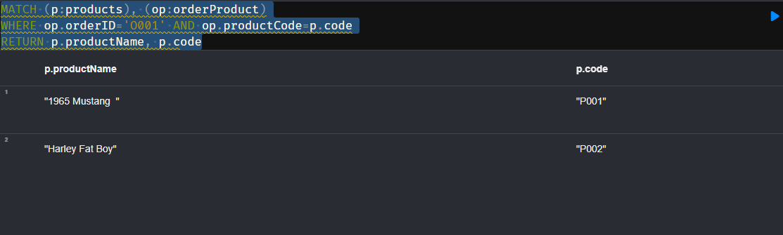
3.2.4 MATCH (p:products), (op:orderProduct)
WHERE p.code=op.productCode
RETURN p.productName
ORDER BY op.quantity DESC
LIMIT 3
